Sum of Sales by Category

Sum of Sales by Order Date

Sum of Sal

es

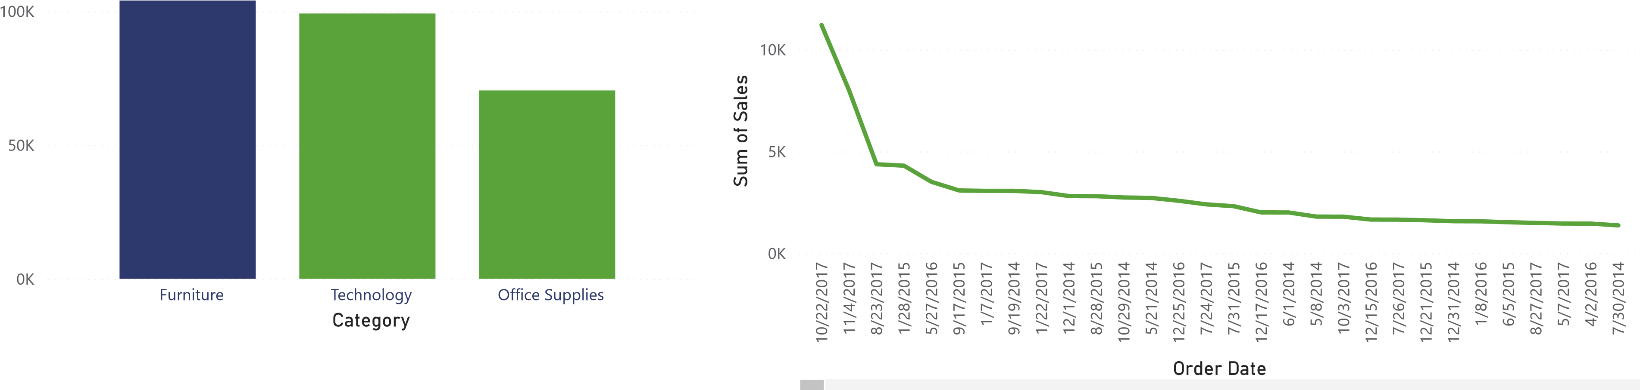

Sum of Profit by Region **Technology Is the second Highest Revenue Category**

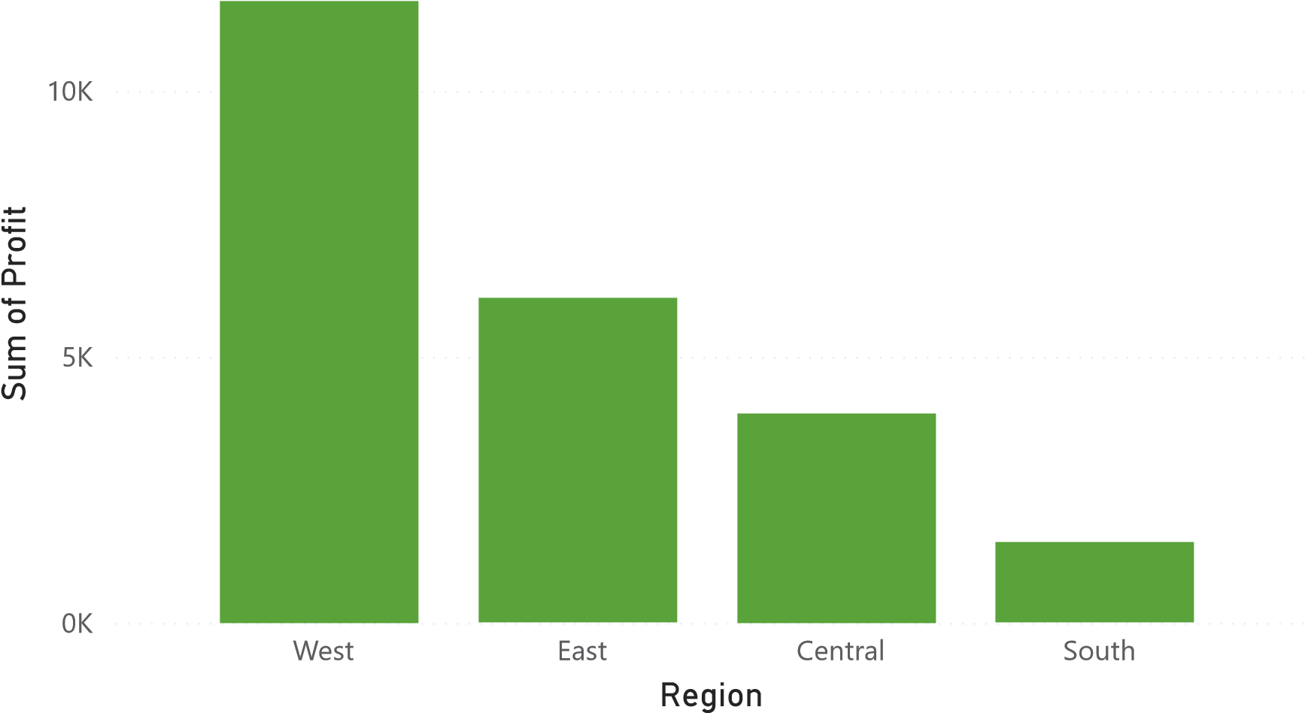23.21K

Sum of Profit

Sum of Sales by Segment **West Region Is the Most Profitable**

(46.41%)

93.93

K (34.38%

)

52.46

K (19.2%

)

126.79

K

# Segment

Consumer

Corporate

Home Office

273.17K

**Consumer Segment Recorded The Highest Sales Among All** Sum of Sales **Segments**

**Total Sales Across All Categories and Segments**

Sum of Sales by Customer Name

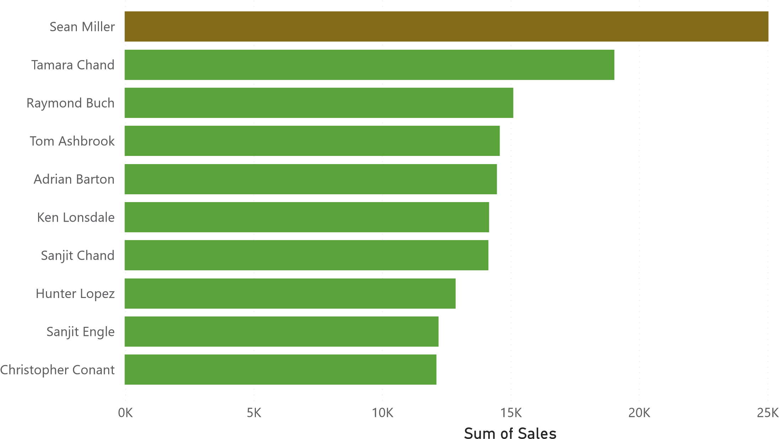 30K

Customer Name

# Top 10 Customers By Total Sales

Sum of Discount and Sum of Profit by Product Name Power BI Desktop

Sum of Profit

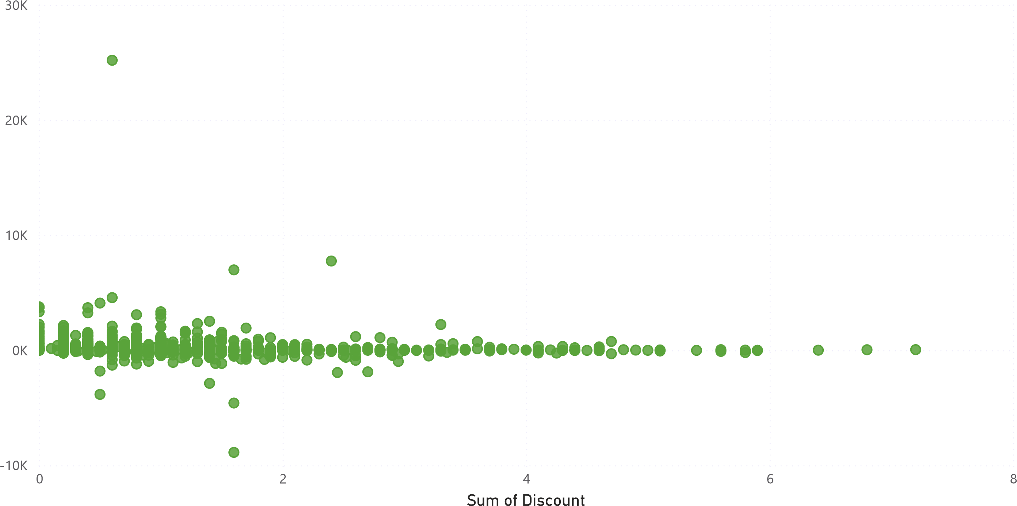

## Profit VS Discount By Product Name

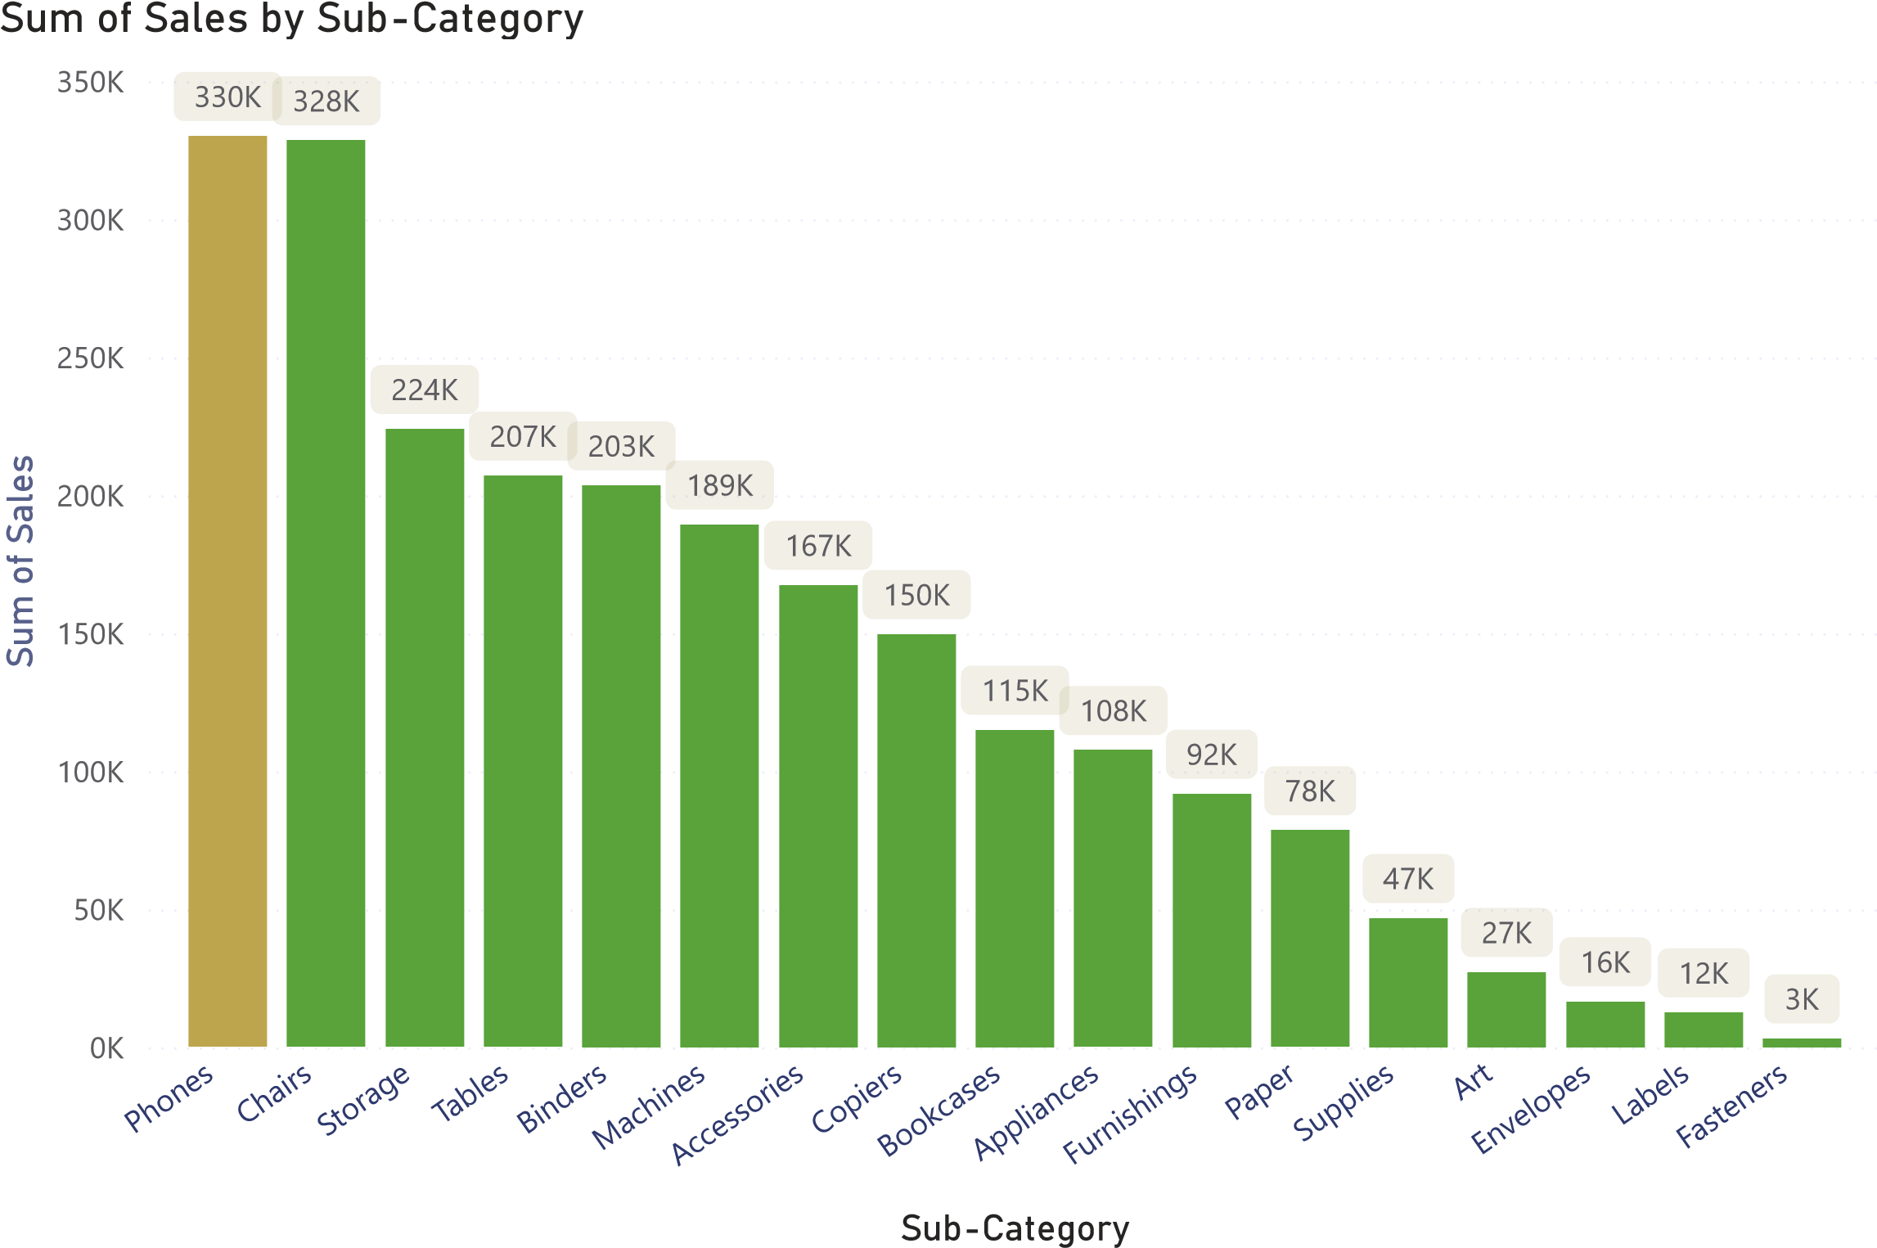

**Phones Generated The Highest Sales Among All Product Sub Categories**